Unit: Making Healthy Cereal Bars | Year 1 | Strand: KS1 – Food and Nutrition
Foods that could go in cereal bars:
Have food tasting sessions with the children – looking at dried fruits, canned fruits, fresh fruits.
Cereals such as oats, barley, bran.

Vocabulary:
Design  Product  Sharp  Blunt  Grater  Texture  Ingredients  Recipe | To plan something which can be made using ideas from different places.  Something which is made from different materials. The book is the product of the design.  having an edge or point that is able to cut or pierce something.  (of a cutting implement) not having a sharp edge or point.  a device having a surface covered with holes edged by slightly raised cutting edges, used for grating cheese and other foods.  the feel, appearance, or consistency of a surface or a substance.  any of the foods or substances that are combined to make a particular dish.  a set of instructions for preparing a particular dish, including a list of the ingredients required

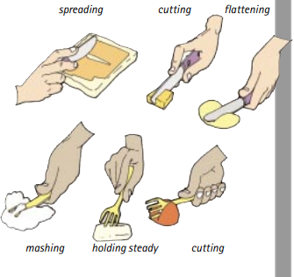
How we use familiar tools.
What will be taught through the unit:
Investigate: | - What is a balanced diet?  - Diet consisting of a variety of different foods and is low in sugar and fats.  - Look at ingredients of cereal bars – how much sugar do they have?  - What other ingredients are there?  - Where do the main ingredients come from?  - What flavours went well together?  - Investigate different combinations with fruit and some vegetables.  - Investigate what adds the sweetness? Honey, sugar, syrup, fruit, chocolate (power) etc…  - What are the benefits of a cereal bar? Convenience, healthier than chocolate.
Design: | - Children design a cereal bar which has only 1 sweeter ingredient.  - Record what will need to happen to each ingredient? Cutting, slicing, chopping, grating, squashing, mashing, peeling etc…  - They draw what they think it will look like: What size, shape, colour they thing it will end up.  - What tools they will need.  - Children label and draw a diagram.  - Design a wrapper for the bar to attract people to it.  - Introduce the idea of a design specification – who is it for? What may they like?
Make: | - Children use different tools to make the bar:  - Knife, grater, spoon, bowls, scales.
Evaluate: | - How did the bar look?  - How did it taste?  - Did the ingredients stick together in a bar? Why/Why not?  - What would they do to improve the bar?
Technological  Knowledge: | - How do we combine ingredients effectively?  - Cutlery and utensils used to prepare ingredients/  - The importance of developing a product that has benefits to health.

Challenge: To make a moving book about Victorian life
- To make a cereal bar
- To evaluate ingredients according to taste, appearance and nutritional value

MANCHESTER ROAD PRIMARY ACADEMY - SCIENCE

