|  |  |  |
| --- | --- | --- |
| **Unit: Making a Mayan Weave Blanket** | **Year 6** | **Strand: KS2 Textiles** |

Useful Websites.

<https://www.youtube.com/watch?v=Ef2-UoadBmk>

<https://www.ancient-origins.net/ancient-places-americas/weaving-world-ancient-mayan-women-001976>

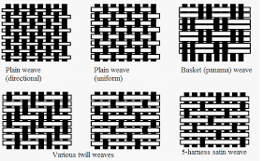Types of weaving

|  |  |
| --- | --- |
| **What will be taught through the unit:** | |
| Investigate: | * The history of Mayan weaving: * Animals were not kept as pets or for industry, so the first fabrics were made from plant fibres. * Fur from American animals was then used to dye and weave on a ‘backstrap’. We know this due to art and text from ancient Mayan times. * After the Spanish invasion some families started to use simple looms. * Where cotton comes from and how it is spun, how wool/ fur is taken from animals and turned into fibres so items such as clothes, rugs and blankets can be made. * Look at Mayan blankets. * Look at the patterns and designs of Mayan fabric – is colourful, and would mainly have been used to cover walls and floors that were dull – also clothes and blankets. |
| Design: | * Children design as a class a whole rug with a theme – split the rug and decide which bits each child will do. * Children design their part of the weave and choose the loom and thread to use. |
| Make: | * Children make their design. |
| Evaluate: | * Children evaluate their work and the result of the work once combined. * Is it fit for purpose? * Does it have the impact expected? |
| Technological  Knowledge: | * Joining materials using tools. |

|  |
| --- |
| **Challenge: To make a Mayan Weave blanket** |
| * To understand the different ways in which materials are joined together to make items. * To know some of the history behind Mayan weaving and textiles, and what the fabrics were used for. * To understand the process of weaving and fabric design. |

|  |  |
| --- | --- |
| **Vocabulary:** | |
| Pattern  Warp  Weft  Fibre  Yarn  Fringe | A design that is repeated.  The vertical threads attached to the loom.  The threads that are woven through the warp.  A long, thin thread of material like cotton or wool.  Fibres such as cotton or silk that have been twisted into long strands.  An ornamental border of threads left loose or used to form tassles. |

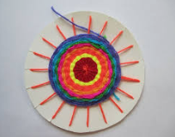

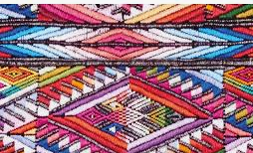 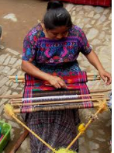

**MANCHESTER ROAD PRIMARY ACADEMY – Design Technology**