|  |  |  |
| --- | --- | --- |
| **Unit: Moving Books** | **Year 1** | **Strand: KS1 - structures** |

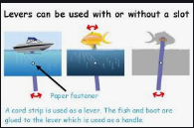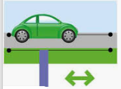

Examples of moving pictures.

|  |  |
| --- | --- |
| **Vocabulary:** | |
| Design  Product  Lever  Accurate  Measure  Evaluate | To plan something which can be made using ideas from different places.  Something which is made from different materials. The book is the product of the design.  a rigid bar resting on a pivot, used to move a heavy or firmly fixed load with one end when pressure is applied to the other.  When you do something carefully so that it is right.  get the size, amount, or degree of (something) by using an instrument or device marked in standard units.  form an idea of how something went. Was the books a success? Why? |

|  |  |
| --- | --- |
| **What will be taught through the unit:** | |
| Investigate: | * Children investigate different types of moving books and pictures. * They evaluate what they like about them, and think about how the parts move. * Children look at different pictures from familiar books and talk about which bits they think would look good for the reader to see move. |
| Design: | * Children look at pictures from the books about flight. They choose which images they are going to use in their books, and how these may move: * A plane flying across the sky * A balloon going up and down * A spaceship flying around * How are images going to be arranged? * That only one picture can move on the page. |
| Make: | * Children construct a lever mechanism:      * Children make a wheel mechanism:        * Children choose and use the correct equipment to make the product. |
| Evaluate: | * Children evaluate using: * Is the book about what was intended? * Did the picture move like they wanted it to? * Did the moving part move well? * What could be done to improve the design? |
| Technological  Knowledge: | * How scissors, pencils, rulers and stencils can be used to create accurate drawings and images. * How to create effects |

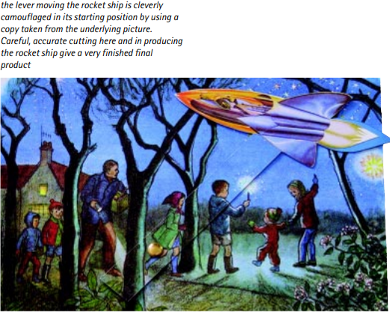

|  |
| --- |
| **Challenge: To make a moving book about Flight** |
| * To make a moving book. * To create different mechanisms in the book so that things move. |

**MANCHESTER ROAD PRIMARY ACADEMY - DT**