**MANCHESTER ROAD PRIMARY ACADEMY - GEOGRAPHY**

|  |  |  |
| --- | --- | --- |
| **Unit: Extreme Earth – The impact of Volcanoes and Earth Quakes** | **Year 6** | **Strand: Human and Physical Geography** |

**Some Extra Knowledge:**

The word volcano originally comes from the name of the Roman god of fire, Vulcan.

The object with the most volcanic activity in our solar system is Io, one of Jupiter’s moons. Covered in volcanoes, its surface is constantly changing due to the large amount of volcanic activity.

Volcanic eruptions can send ash high into the air, over 30km (17 miles) above the Earth’s surface.

Pumice is a unique volcanic rock (igneous) that can float in water.

Scientists use the different speeds of seismic waves to locate the epicentre (the point on the surface directly above where the earthquake originated) of earthquakes.

The most powerful earthquake ever recorded on Earth was in Valdivia, Chile. Occurring in 1960, it had a magnitude of 9.5.

|  |  |
| --- | --- |
| **What will be taught through the unit:**   * **The structure of the Earth’s plates and how they move** * **The impact of plate movement – volcanoes and Earth Quakes** * **The structure of volcanoes and the impact of a volcanic eruption** | |
| Location of key Volcanoes to be idenitified | **(See map)** |
| Tectonic Plates: | * The Earth is made up of a series of tectonic plates. These are constantly moving very slightly. * If there are larger movements, these can have an impact on Earth – Causing Earthquakes and volcanic eruptions. |
| What we know about Volcanoes: | * They are caused when there are weaknesses in the Earth’s crust (tectonic plates). This can be plates moving closer together, further apart or sometimes in the middle of plates where the Earth’s crust is thinner. * The build up of pressure inside the Earth is released, and the magma makes its way to the surface causing a volcanic eruption. * The lava from a volcanic eruption cools and forms new layers of crust. * Over a long period of time, and several eruptions, a volcano forms.   **Worlds most famous volcanoes:**  Mount Vesuvius, near Naples, Italy  Krakatoa, Indonesia  Mount St. Helens, Washington, USA  Conduct a study of Fuego in Guatamala – Impact of Volcanic eruptions.  Incorporate the 3 P’s: PREDICT PROTECT PREPARE  <https://www.bbc.co.uk/news/world-latin-america-46261168> |

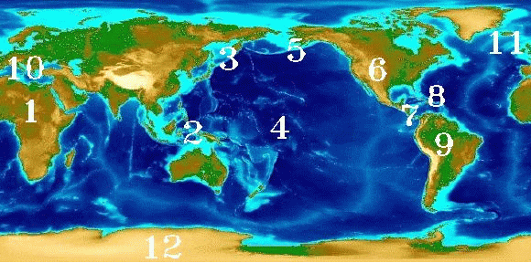

**The main Volcanic regions on Earth.**

**Know what the key volcanoes are in each area.**

<http://www.geo.mtu.edu/volcanoes/world.html>

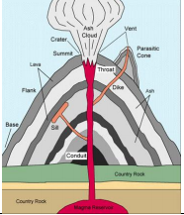

|  |  |
| --- | --- |
| The Structure of the Earth: |  |
| What we know about earthquakes: | * The tectonic plates which sit on the Earth’s mantle move slightly. If the plates move at different speeds, it causes pressure, and this can cause an earthquake. * The san Andreas fault is the most famous place for researching earthquakes – here the plates move at different speeds, and small earthquakes are recorded up to 10 times a day. * Earth quakes are measured using the Richter Scale: |
| How 3P’s can impact positively and negatively on the damaged caused by natural disasters. | * Investigate the social, economic, environmental impact of Volcanic eruptions and Earthquakes. |

|  |  |
| --- | --- |
| **Vocabulary:** |  |
| Crust | The rocky outer layer of the Earth. |
| Mantle | Semi – molten rock beneath the Earth’s crust. |
| Inner core | A dense solid of extreme temperature made up of iron and nickel |
| Outer core | A 2000km thick liquid made up of mainly iron and nickel |
| Tectonic plates | Huge plates that make up the Earth’s crust. |
| Plate boundaries | Where 2 or more tectonic plates meet |
| Magma | Molten rock from the mantle before it reaches the surface of the Earth. |
| Lava | Molten rock released from the Earth’s core by a volcano. |
| Volcano | A vent in the Earth’s crust from which lava gas and ash are released. |
| Earthquake | A sudden shaking of the ground caused by movement in the Earths crust. |
| Crater | A bowl – shaped basin at the top of a volcano. |
| Vent | The central tube which magma travels through |
| Cone | The hill produced around a volcano by the eruption of lava and ash |
| Active | Volcanoes which erupt frequently |
| Dormant | Volcanoes which have not recently erupt but could still erupt. |
| Extinct | A volcano which is unlikely to ever erupt again. |
| Economic | Anything to do with money and people’s ability to make money. |
| Social | Anything which affects people and families |
| Environmental | Anything which effects animals, plants and eco – systems. |
| Prediction | Attempting to know when a volcanic eruption or earthquake will occur using equipment. |
| Preparation | Creating a plan to deal with a disaster. |
| protection | Reducing the damage that can be caused. |
| Seismometer | A machine which record vibrations in the crust. |
| Richter scale | A scale used to measure the vibrations of the Earth’s crust. It goes from 1-10 |
| Infrastructure | Basic physical facilities in an area such as water, electricity, hospitals etc… |
| Aid | Money given to help a country by another country. |