**MANCHESTER ROAD PRIMARY ACADEMY - GEOGRAPHY**

|  |  |  |
| --- | --- | --- |
| **Unit: Llandudno** | **Year 4** | **Strand: Human and Physical Geography** |

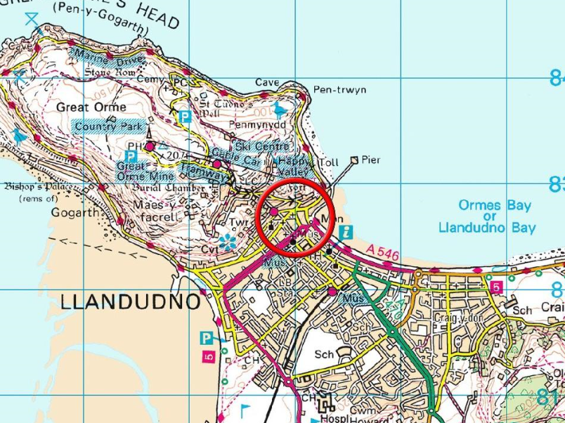

|  |  |
| --- | --- |
| **What will be taught through the unit:**   * **The geographical features of a seaside resort – Llandudno** * **The similarities and differences in the key features of a town and a seaside resort.** * **How to study a particular area for its land use and physical geography** | |
| The Geography of Wales | * Wales is a country in the United Kingdom. * It’s capital city is Cardiff, which is in South Wales. * The physical geography is carried – with flat peninsulas and high mountains. * There are 3 National Parks in Wales: Snowdonia, the Brecon Beacons and Pembrokeshire Coast. * Topography and OS maps will show children the varied landscapes:      * Grid references are used to find places on a map. What is the 4 figure grid reference for Llandudno? Droylsden? Egypt? Greece? |
| Llandudno – location and key features | * Llandudno is a seaside town and community in North Wales. It is in the borough of Conwy. * It is located on the Creuddyn Peninsula which protrudes into the Irish Sea. * The River Conwy has it’s entry to the sea in Llandudno. * Llandudno is one of Wales’ largest seaside resorts. * The Great Orme is a huge landmark made from limestone which stands 679ft tall. It is home to many rare species of flora and fauna. * The development of the seaside town took place during the early Victorian period when seaside holidays became very popular. * The resort has a tramway which carries passengers to the top of the Orme. It has a pier, a Victorian seafront with many huge Victorian hotels creating a spectacular promenade, and a main shopping street (Mostyn Street) consisting of many different types of shops and outlets. It has a golf course and a small zoo. |

**Llandudno is a ‘Honey Pot’ site.**

A honeypot site is a **location attracting throngs of tourists** who, due to their numbers, place pressure on the environment and local people. Honeypots are often used by cities or countries to manage their tourism industry. The use of honeypots can protect fragile land away from major cities while satisfying tourists.

|  |  |
| --- | --- |
| Comparing Llandudno to Droylsden | * There are many features of Llandudno that can also be found in Droylsden – this is because they are both towns. Features such as shops, cafes, library, supermarket, swimming pool etc… Differences would include hotels and B&B’s, gift shops, pier, seaside. Children can speculate about this and discuss why they would have these differences. |
| To use key geographical vocabulary when communicating understanding. | * Climate zones are different all over the world. The climate zone in Llandudno and in Droylsden is temperate maritime – the weather is mild and wet. * The geography and geology of places effect how the land is used. I Llandudno, there are occupations which will not exist in Droylsden associated with the tourist industry – but the vast majority are very similar. |
| Developing Field work skills | * When visiting the area, children collect data on traffic, building use and on occupations. |

<https://kids.kiddle.co/Llandudno>

<https://www.visitconwy.org.uk/>

<https://www.bbc.co.uk/bitesize/subjects/zbkw2hv>

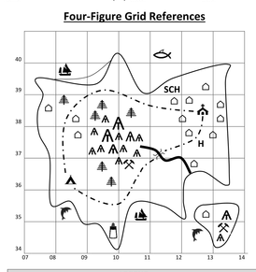

4 figure grid references are not co – ordinates. The figures are read along the bottom and to the right, then up the side and to the square above.

|  |  |
| --- | --- |
| **Vocabulary:** |  |
| biome | A natural source of vegetation and animals |
| climate | The general weather conditions typical of a place |
| Coast |  |
| Cliff |  |
| Promenade |  |
| Pier |  |
| Grid reference |  |
| Ordenance survey |  |
| Region |  |
| National park |  |
| Sources |  |
| Comparison |  |
| Physical geography |  |
| Human geography |  |
|  |  |
|  |  |
|  |  |
|  |  |
|  |  |
|  |  |