MANCHESTER ROAD PRIMARY ACADEMY - HISTORY
Unit: Changes in Britain Through time: The Anglo – Saxons and Vikings | Year 5 | Strand: Changes In Britain Through Time

What will be taught through the unit:
- That after the fall of the Roman Empire the Anglo Saxons invaded different parts of Britain.
- Anglo – Saxons set up many settlements and began many elements of society as we know them today.
- The Vikings invaded Britain in order to claim land and riches.

The Anglo – Saxon invasions | - After the fall of the Roman Empire, Britain became more open to attack and invasion.  - The Anglo – Saxons were made up of 3 tribes from across Europe: The Angles, Jutes and Saxons.  - The Anglo – Saxons had tried to attack Britain earlier – but the Roman had fought them off.  - They arrived in Britain in long wooden boats across the North Sea.  - It is believed that changes in the weather (flooding and cold temperatures) caused the Anglo – Saxons to travel to Britain.
Anglo – Saxon life | - The Anglo – Saxons were farmers and warriors.  - When they arrived in Britain, they did not like the stone roads and buildings that the Romans had left behind, so they destroyed some of them and built villages and settlements in the forests and farm land.  - Some Chiefs realised the value of a high Roman wall – and built their settlements inside them for protection.  - Different kingdoms were formed during Anglo – Saxon rule, and these were ruled by their own Chief. This in itself caused a lot of conflict between tribes.  - By the end of Anglo – Saxon times there was only 1 kingdom ‘Mercia’. This was ruled by Alfred the Great.  - Alfred was one of the only kings to be called ‘great’  - He fought the Vikings, but then made peace and encouraged people to live together.  - He made good laws and believed in education – he asked the monks to start writing about life at the time.  - We know little about life during these times… They were known as ‘The Dark Ages’ because of lack of information and evidence.  - Evidence collected has been formed from the ruins of settlements.
Sutton Hoo | - A lot of what we know about Anglo – Saxon life is from the burial Site at Sutton Hoo.  - There are 11 mounds there, and when one was excavated, a ship was found.  - Inside the ship was a grave. This showed how much care the Anglo – Saxons took of their dead and what they believed about the after life.  - There are many objects recovered from the site to think about and discuss – Who was the person buried there?

Historical Enquiry:
- Why would weather conditions cause people to travel and invade other countries?
- How are place names around Britain related to the leader or chief of the tribes who lived there?
- How do the beliefs about the after – life compare to what the Ancient Egyptians believed.
- What information do objects from the Sutton Hoo burial sites tell us?
- How do we know about the Vikings? What evidence is there?
- Viking place names… How do we identify them?

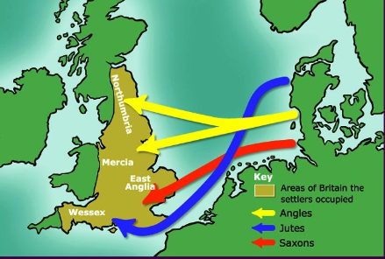 Anglo – Saxon Invasion
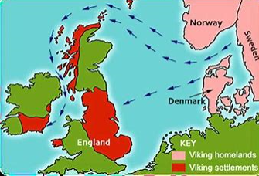 Viking Invasion

The Viking Invasion | - Vikings travelled to Britain across the North Sea from Norway, Denmark and Sweden.  - The name ‘Viking’ comes from Norse language and means ‘Pirate raid’.  - Some Vikings came to Britain to plunder and battle, but many came in peace to settle and set up farms and long houses where they could live together.  - Vikings brought with them different beliefs, and told stories of gods and magic which were different to the beliefs of the Christian Anglo – Saxons.  - After many years of battles, the Vikings had taken almost all of the kingdoms of Britain – except Wessex, which was ruled by Alfred the Great.
The attack on Lindisfarne | - In AD793 the Vikings famously attacked the monastery in Northumbria called Lindisfarne.  - The Vikings were Pagans - -so did not care much about the building. The monks had no weapons, but had lots of riches, including gold, food, drink, cattle and tools.
The end of Viking rule | - After years of peace, the Anglo Saxons began to reclaim land and rule from the Vikings. In 954 they pushed out the last Viking King from York.  - Edward the confessor was the King of England from 1042 to 1066. He died without leaving an heir, and this led to Britain being invaded again by the Normans.  - The Normans won during the battle of Hastings in 1066, when they defeated the new King Harold.  - This ended the Anglo – Saxon/ Viking rule and began the era of Norman rule.
Vocabulary:
Invasion | Instance of invading a country or region with an armed force
Kingdom | Country, state or territory ruled by kings or queens
Settlement | A place, typically one that has been previously uninhabited, where people establish a community
AD | Anno Domini – used to indicate that a date comes the specified number of years after the birth of Christ.
BC | Before Christ
Population | All the inhabitants of a particular place
Resistance | The use of force to oppose something
Inhabitants | A person or animal that lives in or occupies a place
Longboats | A long boat that Vikings used to invade the United Kingdom
Conqueror | A person who conquers a place or people
Burials | A ceremony at which someone’s body is buried
Archaeology | The study of human history and prehistory through the excavation of sites and the analysis of artefacts.

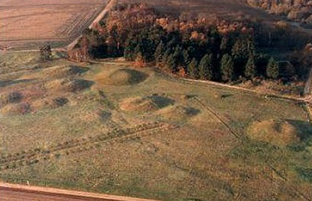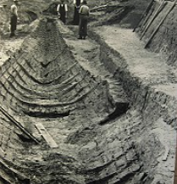
Sutton Hoo
Trips/ Visits & Useful Websites:

http://www.primaryhomeworkhelp.co.uk/saxons/suttonhoo/index.htm
https://www.bbc.co.uk/bitesize/topics/zxsbcdm/articles/z8q487h

Timeline of Significant Events:
