**MANCHESTER ROAD PRIMARY ACADEMY - HISTORY**

|  |  |  |
| --- | --- | --- |
| **Unit: Significant People from the Past** | **Year 2** | **Strand: The lives of Significant Individuals** |

**Historical Enquiry:**

* **Children think about how people can change the world we live in – both in the past and modern inventors.**
* **Consider versions of events in the past using evidence.**

|  |  |
| --- | --- |
| **What will be taught through the unit:**   * **That there are many people in history who have been significant in making changes.** * **That Neil Armstrong and a team made history in 1969 by travelling to the moon.** * **That Grace Darling was a significant person from the past who saved people from a disaster at sea.** | |
| Significant people from the past made changes that still effect our lives today: | * There are many people from the past who have made a difference through history. * Amy Johnson, Louis Braille, Scott of the Antarctic, Time Berners Lee (WWW), Alexander Graham Bell, Steve Jobs, Mark Zuckerberg. |
| The Moon Landing: | * Neil Armstrong was an astronaut who worked for NASA( National Aeronautics and Space Administration). * Neil was born the oldest of 3 children in Ohio U.S.A. Neil Armstrong died on the twenty-fifth of August 2012 aged 82. * Neil was Commander of the Apollo 11 space mission to be the first crew to orbit and land on the moon. * Neil Armstrong was the first man to walk on the moon. * His Famous quote upon landing was: “One small step for man, one giant leap for mankind.” “The Eagle has landed.” * Crew of Apollo 11 were Neil Armstrong and two other astronauts. Their names were Buzz Aldrin and Michael Collins. * Apollo 11 landed in the Pacific Ocean on their return to Earth. |
| Grace Darling: | * **Grace Horsley Darling** (24 November 1815 – 20 October 1842) was an English [lighthouse keeper](https://en.wikipedia.org/wiki/Lighthouse_keeper)'s daughter, famed for participating in the rescue of survivors from the shipwrecked [*Forfarshire*](https://en.wikipedia.org/wiki/Forfarshire_(ship)) in 1838 * Grace and her father were said to rescue 62 people from the sea during a storm. This made Grace a national hero. As a result of this, Grace and her father were awarded the Silver Medal for bravery by the Royal National Institution for the Preservation of Life from Shipwreck. * There are different accounts of the rescue that Grace Darling performed – why does this happen?   Grace Darling |

Here are pictures of Neil Armstrong as a baby, landing on the moon and of Neil in later life. You can see the flag of the United States of America.

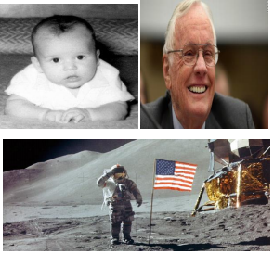 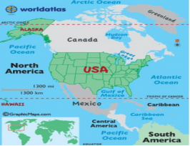

This is where Neil Armstrong was born in North America. You can see the Pacific Ocean labelled.

**Useful Websites and Visits:**

**Jodrell Bank**

<https://www.keystagehistory.co.uk/keystage-1/>