MANCHESTER ROAD PRIMARY ACADEMY - HISTORY
Unit: Flight | Year 1 | Strand: Significant people and Events

What will be taught through the unit:
- That the invention of aircraft has developed over a period of time.
- That significant people have made record - breaking flights around the world over the last 100 years.
- That the pilots in early flights have paved the way forward for the aircraft we have today.
The history of flight: | - First attempts at flight began hundreds of years ago when people investigated and built kites.  - In the 18th Century people experimented with designing gliders.  - In 1783 the first hot air balloon was invented.  During the mid – 20th century, planes were designed to carry people, and were powered by engines. This led to many record – breaking flights to different places around the world.  In 1970 the first passenger aircrafts took flight.
Future Flight: | There are inventions currently being developed:  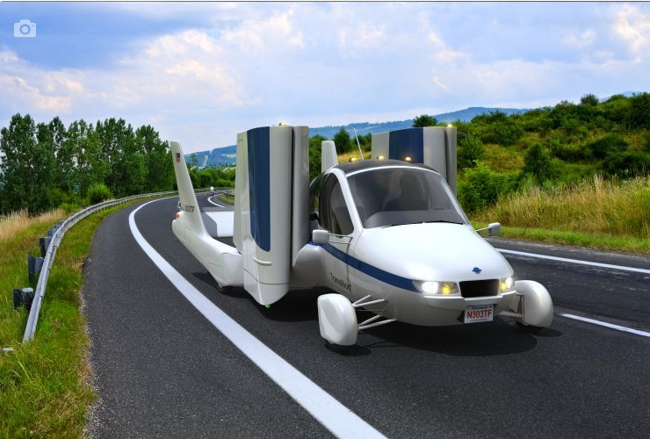 flying cars, solar powered aircraft.
Amy Johnson | - Amy Johnson used to fly as a hobby.  - In 1030 she became recognised for being the first woman to fly solo from England to Australia.  - She received the Harmon trophy as well as a CBE.  - After flying to Australia, she then broke another record – flying to Moscow from England in one day. She then flew across Siberia to Japan.  - In 1932, she set another record flying from England to Cape Town.  These flights were challenging, as there were mechanical problems, challenging weather and many crashes!  Amy died transporting an aeroplane on what should have been a simple journey. Her plane crashed in the River Thames and her body was never found.

Historical Enquiry:
- To investigate photos and drawings of aircraft from the past.
- To look at evidence and consider how people have different points of view about events.
- To consider the impact early flight has had on society today.

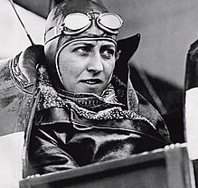

Vocabulary
Aviation | The design and manufacture of aircraft
Invention | A new product that did not exist before
Flight | Things that pass through the air
Glider | A motor less aircraft
Engine | A machine that converts energy to power
Aerial | Of, in or produced by the air
Event | Something important that happens
Evidence | Something which proves or disproves something.
Timeline | A sequence of events in time order.

Timeline of Significant Events:
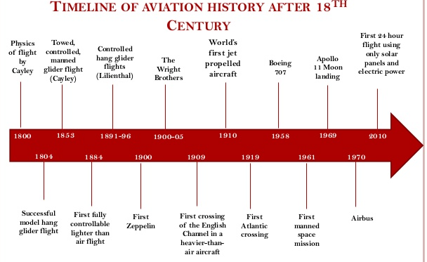

The Wright Brothers: | - Orville and Wibur Wright were 2 American brothers who built the world’s first successful aircraft in 1903.  - In 1900, the Wright brothers first tested an unmanned glider and flew it like a kite. After a collaboration with Octave Chanute, builder of the Chanute-Herring Double-Decker, Orville and Wilbur built a manned biplane glider that was larger to carry more weight.  - They chose the sand dunes at Kill Devil Hills for high winds and soft sands.  - Between October to December 1901, they conducted several aerial experiments to learn the effects of airflow over different wing shapes.  - After their findings using the wing tunnel, the Wright brothers built a new glider with a 32-foot wingspan. The new biplane-design glider was tested and flew for 26 seconds at 622 feet. They replaced the tail with a movable rudder.  - Upon the success of the new glider, they decided to build a powered flying machine, which could fly over long distances. For six weeks, Charlie Taylor built the four-cylinder aluminum engine based on the designs of Orville and Wilbur.  - The first powered biplane was called “The Flyer”, which included a propeller, weighed 200 pounds and produced about 12 horsepower.  - At first, governments were doubtful about the inventions – but the brothers persevered.  - They invented aeroplanes with seat which were sold around the world, and they became wealthy men.  - They are known as the fathers of flight.  - Wilbur died of illness in 1912. Orville ran the company until 1915, and then sold it. He was always heavily involved in aviation.  - Orville died in 1948.
Trips/ Visits & Useful Websites:
https://www.bbc.co.uk/bitesize/clips/z82xpv4
https://www.keystagehistory.co.uk/keystage-1/outstanding-lessons/amy-johnson-and-wright-brothers/
http://www.bbc.co.uk/humber/content/articles/2005/10/18/amy_johnson_feature.shtml

