**MANCHESTER ROAD PRIMARY ACADEMY – Religious Education**

|  |  |  |
| --- | --- | --- |
| **Unit: Who is a Christian and what do they believe?** | **Year 1** | **Strand: Believing** |

|  |  |
| --- | --- |
| **Vocabulary:** |  |
| Holy Trinity | The 3 persons believed to be in God: The Father, The Son and the Holy Spirit |
| Creator | A person or thing that brings something into existence |
| God | The Christian creator and ruler |
| Jesus | The central figure of Christian Religion |
| Miracle | An extraordinary and welcome event not brought about by natural or scientific laws and is therefore seen as divine. |
| Bible | Christian scriptures consisting of the old and new testaments. |
| Belief | An acceptance that something exists. |
| Prayer | A solemn request to a god or other deity. |
| Worship | Expression of faith towards a particular god or deity. |
| Christians | A person who believes in Christianity. |

|  |  |
| --- | --- |
| **What will be taught through the unit:**   * **To be able to talk about Christians beliefs** * **To recognise some familiar Christian symbols and images.** * **To retell a story that shows what Christians might think about God.** | |
| Books and Stories: | * The book of Jonah is a set of 4 chapters from the Old Testament telling about how Jonah was sent by God to a city to get it’s people to believe in him. It tells of Jonah’s thoughts and beliefs and what god did because the people did not believe. * The Lost son Luke 15 11-32 tells the story of how two brothers were given wealth from their father and did very different things with it. One son squandered all the wealth and had to go back to his father and ask for forgiveness. * The story of the Pentecost. Jesus promised his disciples that after his death he would send the Holy Spirit for them. He kept this promise. The arrival of the Holy Spirit was a dramatic event in the bible. He appeared in a huge gush of wind, and the disciples all began speaking in different languages. This story shows why Christians believe God is all around us. * There are many stories in the bible that show what Christian believe about god, and how they teach people how to live their lives well. These include ‘The Good Samaritan’ (Luke) and ‘Let my People Go’ (Exodus) <http://bibleappforkids.in/blog/bible-stories-miracles/> |
| Key Aspects: | * Christians believe that Jesus Christ was the Son of God and that: * God sent his Son to earth to save humanity from the consequences of its sins * Jesus was fully human, and experienced this world in the same way as other human beings of his time * Jesus was tortured and gave his life on the Cross (At the Crucifixion) * Jesus rose from the dead on the third day after his Crucifixion (the Resurrection) * Christians believe that Jesus was the Messiah promised in the Old Testament   Christians believe that there is only one God, but that this one God consists of 3 "persons" (The Trinity). For some Christians, the sign of the trinity is a cross which can be made across the chest.   * God the Father - God himself * God the Son – Jesus as a person * The Holy Spirit – The spirit of Jesus that lives in us all * Christians believe that God made the world, that he is powerful, that he is loving, forgiving and that he is always close. |

Christian Symbols:





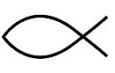

The cross reminds Christians that Jesus came to save them.

The Dove is the symbol for the holy spirit and peace.

Jesus Christ God’s son saviour

**Christianity and ideas about what god may look like are represented in poetry,art and architecture:**

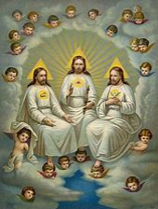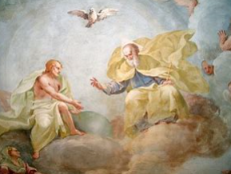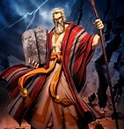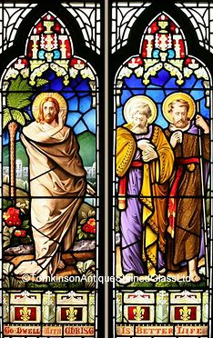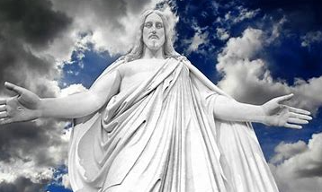

**These images are produced to show what Christians believe about God - caring, powerful, forgiving.**

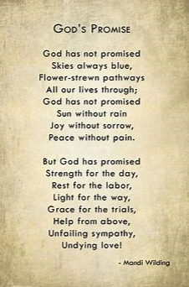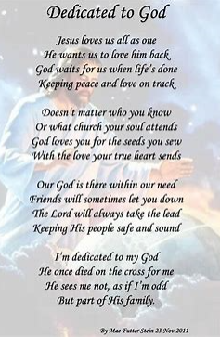

**Trips/ Visits & Useful Websites:**

[**http://bibleappforkids.in/blog/bible-stories-miracles/**](http://bibleappforkids.in/blog/bible-stories-miracles/)

**Visit to a local church**

[**https://www.theschoolrun.com/homework-help/christianity**](https://www.theschoolrun.com/homework-help/christianity)