**MANCHESTER ROAD PRIMARY ACADEMY – Religious Education**

|  |  |  |
| --- | --- | --- |
| **Unit: Why do people think God exists?** | **Year 5** | **Strand: Believing** |

|  |  |
| --- | --- |
| **What will be taught through the unit:**   * **Find out about how many people across the world and in the locality believe in God.** * **Explore reasons why people do and do not believe in God.** * **To consider what Christians believe about creation.** | |
| Books and Stories: |  |
| Key Aspects: | There are 5 main beliefs across the world (see diagram) 3 of these have some sort of belief in God   * <https://www.ons.gov.uk/peoplepopulationandcommunity/culturalidentity/religion/articles/religioninenglandandwales2011/2012-12-11>   The ONS collected data from the 2011 census. This shows national data for religions across the UK.    There are more Christians in Britain than the global average – this is due to our historical past and the invasion of Britain by several Christian cultures. The amount of people following a religion of any sort is falling. In the 2001 census there were almost 6 million people more who stated no religious belief. Children can consider why this may be happening: use of technology to discover truths, more communication between different communities of belief, science being shared, world conflict, less time to attend religious places of worship due to working patterns, less people practising due to changes in culture.  Clarify with children the beliefs Christians have about God: Some of this comes from the reading of the bible. What are some of the Christian phrases and metaphors used for god? Father, son, holy spirit, eternal almighty, shepherd, rock, fortress, light. Other religions believe different things about god. |

|  |  |
| --- | --- |
| **Vocabulary:** |  |
| **Theism** | **A belief in God** |
| **Atheism** | **The belief there is no God** |
| **Bible** | **The holy book for Christians and Jews** |
| **Eternal** | **Something that lasts forever** |
| **Fact** | **Something that is true** |
| **Belief** | **A feeling that something exists** |
| **Opinion** | **Something you think or believe** |
| **Design** | **Deliberately planned or made** |
| **Opinion** | **Something you think or believe** |
| **Design** | **Deliberately planned and made** |
| **Random** | **Does not follow a design or pattern** |
| **Big Bang Theory** | **A theory that suggests the Earth was created as a result of a large explosion** |

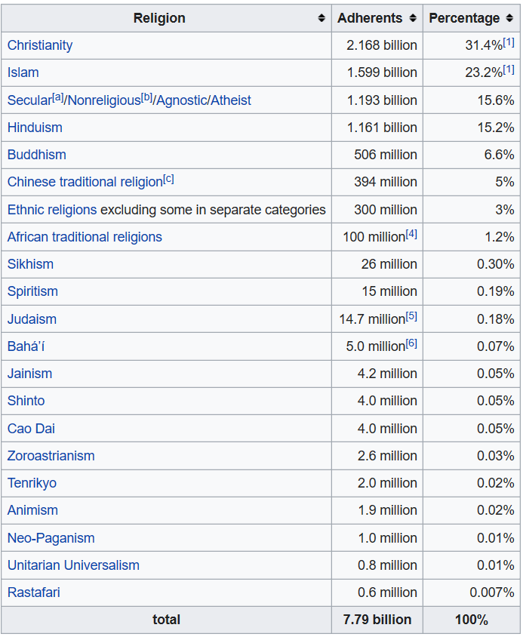

|  |  |
| --- | --- |
|  | There are many reasons why people do and do not believe in God: their home background, religious experience. Lack of evidence, scientific research, the suffering in the world. Some people believe there is no reason to use a creator to explain the existence of the universe and life.  Christians believe in the creation of the world through the story in Genesis.  Believing in God impacts the ways in which some people live:  Foods that are eaten, clothing, prayer and worship, daily life.  There are possible benefits and challenges to believing in God in Britain today. |

Useful Websites and Resources:

<https://humanism.org.uk/campaigns/religion-and-belief-some-surveys-and-statistics/census-2011-results/>