Unit: Animals Including Humans | Year 1 | Strand: Biology
What will be taught through the unit:
What are vetebrates? | Vertebrates are animals that have a backbone.  There are 5 groups of vertebrates:  - Mammals  - Fish  - Birds  - Reptiles  - Amphibians
What is a mammal? | - Give birth to live young  - Usually have hair or fur  - Warm – blooded  - Some common mammals are:  - Pets such as dogs, cats, hamsters.  - Farm animals such as cows, sheep and horses.  - Wild animals such as foxes, hedgehogs, lions, giraffes.  - Humans
What are fish? | - Have fins and scales  - Breathe underwater using gills  - Lay eggs in water  - Cold – blooded  - Some common fish are salmon, tuna, cod, haddock, bass
What are birds? | - Warm – blooded  - Have wings and beaks  - Have feathers  - Lay eggs  - Some common birds are ducks, chickens, penguin and pigeons.
What are reptiles? | - Cold blooded  - Lay eggs  - Live on land and water – can breather underwater through gills  - Some common amphibians are toads and frogs.
What are invertebrates? | - Invertebrates are animals that DO NOT have a backbone.  - They include:  - Insects such as flies, ladybirds and bees.  - Arachnids such as spiders  - Molluscs such as snails
What are the main part of the human body? | Children learn the main body parts, including:  Neck, head, arm, elbow, legs, knees, face, ears, eyes, hair, mouth, teeth, nose, chin, cheek, shoulder, wrist, ankle, toes, fingers, chest.  Use songs and rhymes and diagrams to label.

Investigation/s:
- Observe creatures in the local environment or through media.
- Research how to take care of animals carefully.
Vocabulary:
Backbone  Cold - blooded  Environment  Farm  gills  warm – blooded  Temperature  Pet  Wild | The column of small linked bones down the middle of your back.  A body temperature that changes according to the surrounding temperature  All the things around that influence life.  And area of land used to grow crops or breed animals.  Organs on the side of fish and other water creatures that allow them to breathe  A fairly high body temperature that is not effected by the surrounding temperature.  How hot or cold something is.  A tame animal kept in a household  Animals or plants that live and grow in natural surroundings and are not looked after by people.

What do animals eat?
Animals that only eat meat (other animals) are called carnivores.
Animals that only eat plants are herbivores.
Animals that eat plants and meat are called omnivores.

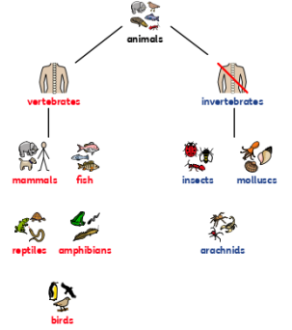
What I Should Already Know:
- The names of some common animals
- Parts of the human body and how they are associated with the senses.

MANCHESTER ROAD PRIMARY ACADEMY - SCIENCE

